Supply Chain Disruption:

The Real Cause of Inflation

Joshua Simangunsong

Johns Hopkins University – School of Advanced International Studies

May 23, 2022

**Research Question**

***How much of the increase in inflation is explained by supply chain disruption or monetary policy?***

COVID-19 was a large shock to the world. It forced many people to leave the labor force. By April 2020, the labor participation rate declined to 60.2%, a sight that has not been seen since the early 1970s. A solution was required. The federal government decided to pass legislation to allocate stimulus checks to alleviate the economic loss that was experienced across households due to the pandemic and increased unemployment. The U.S. Federal Government passed the CARES Act on March 27th, 2020, allocating over $2 trillion to all qualifying adults of up to $1200. As a result, the money supply had increased from the central banks exercising monetary tools such as quantitative easing. This was all in hopes of stimulating the economy into more spending because of the pandemic shock to businesses worldwide. Milton Friedman had said, “Inflation is always and everywhere a monetary phenomenon.” Friedman’s monetary phenomenon was derived quantitatively through the theory of money equation - MV=PQ. So, if real GDP (Q) and velocity (V) were to grow at a constant, this would also express that any increase in money supply (M) should increase prices (P). Yes, it’s true that the money supply has increased due to quantitative easing (QE), but that does not tell the entire story. An important detail that was overlooked was that there was a methodology change in how the M1 money supply was measured. In May 2020, the Fed decided to add saving deposits and checkable money funds to M1; these saving deposits and checkable money funds were originally from M2. This methodology change can be seen in *figure 1* and *figure 2*.

*Figure 1:*

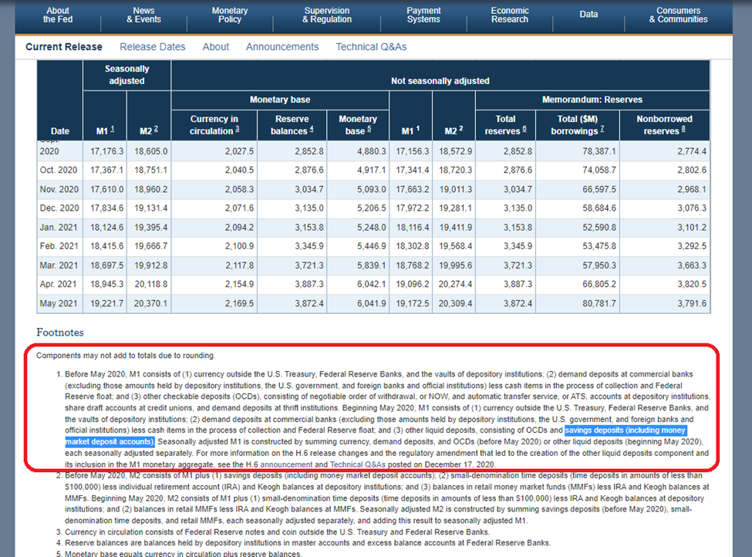

Figure *1* shows that there has been a methodology change in measuring M1 money supply; saving deposits and checkable money funds have been added.

*Figure 2:*

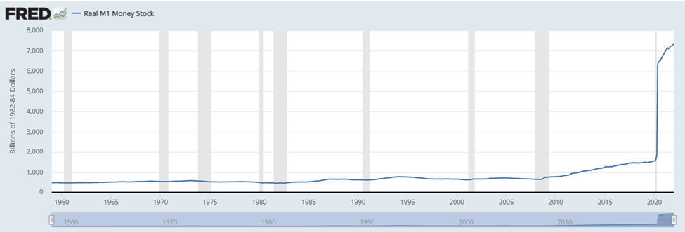

In *Figure 2*, we can see that the Real M1 Money Stock had increased significantly in 2020, during COVID. This was during the time when QE had become rampant and considered normal, with the intention of alleviating economic damages.

So, the increase from $4.9 billion to $16.2 billion in a single month was not solely due to printing, but to its change in methodology. Surely, the amount of money that was printed was put to use, with the intent of alleviating the economic damage from the pandemic was not used because velocity measures the circulation of money, which is at its lowest in history – seen in *figure 3*.

*Figure 3:*

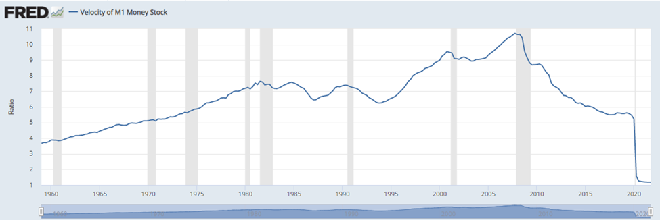Above, we can see that economic activity has hit its low, despite the monetary policy of QE.

Despite the money supply increasing, from both printing and a methodology change, the money was not being circulated and used in the economy. This could not have been an unemployment issue either because, in *figure 4*, you can see that the velocity of money and employment have not been corresponding ever since the financial crisis in 2008 - 2009.

*Figure 4:*

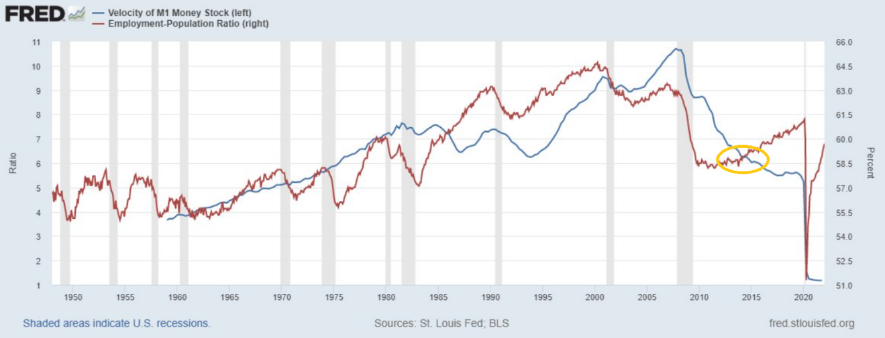In *Figure 4,* employment and economic activity are no longer correlated since post-recession (2007-2008) and COVID.

Although the economy has a high employment rate, this does not translate that money is being circulated into the economy anymore. That generally used to be the case prior to a decade ago, because employment would be associated with more spending, and more spending means more money circulating into the economy. The evidence of this change can be seen in *figure 4, above.*

However, ever since QE, employment and velocity of money are no longer correlated. We also know that all this new money was not being spent. The money supply progressed further than nominal GDP, which means that nominal GDP was not driven by the excess money supply. Rather, it’s been sitting in between the banks and central banks. This can be seen in *figures 5* and *6.*

*Figure 5:*

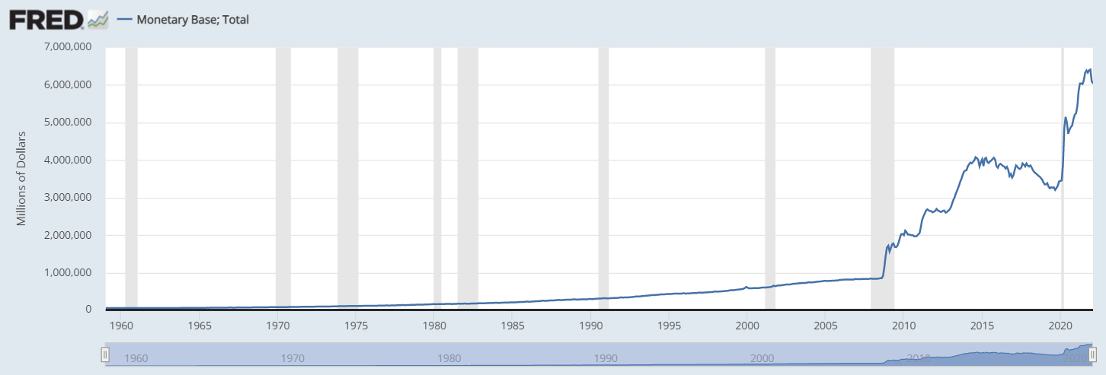

*Figure 6:*

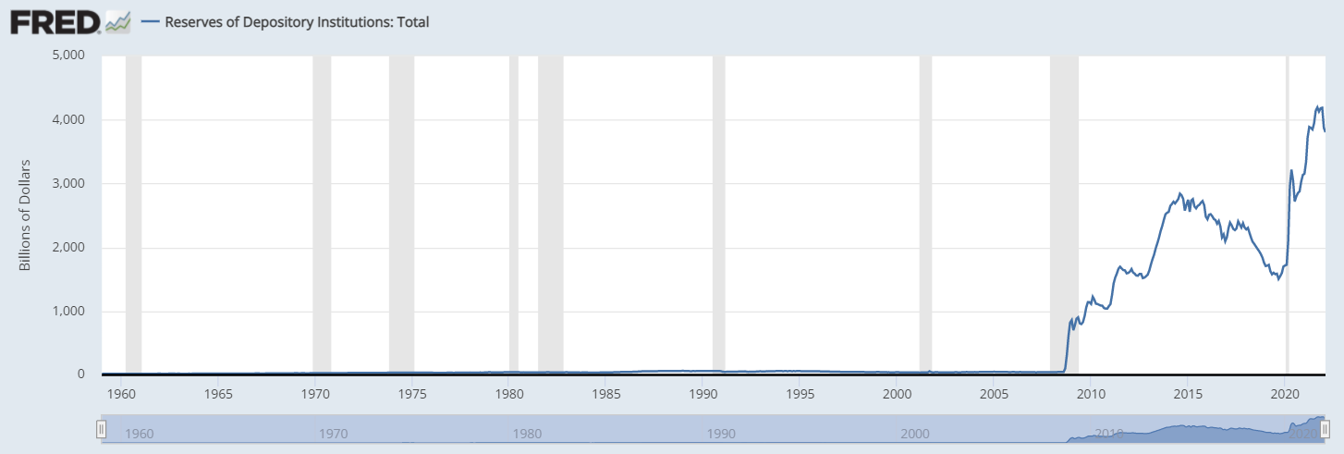The amount of deposits that banks hold in the central bank’s reserves have been increasing, at a rate of M1, but contrasting economic activity (M1 Velocity).

If we have been seeing that the money supply has been increasing, due to QE, since the Great Recession back in 2008, but we have not seen inflation yet. However, we are seeing it now in the response to COVID-19 and it’s not solely because the Federal Reserve is conducting quantitative easing. Therefore, inflation is not to be blamed for quantitative easing, but COVID. Specifically, due to the problem of the disruption of the supply chain due to COVID. This can be seen in the regression below, *figure 7*.

*Figure 7*

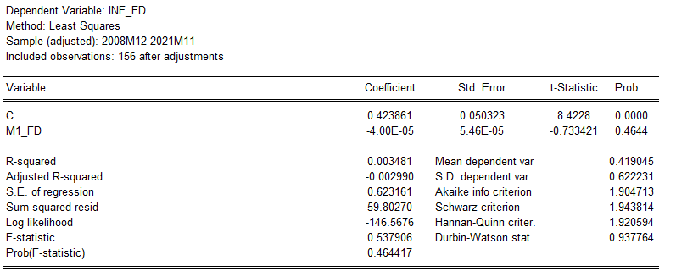

*In, Figure 7, M1 money supply is not statistically significant at the 10% level in explaining inflation.*

This could be clearly understood through Nassim Nicholas Taleb’s idea of convexity, in his book *Antifragile: Things That Gain from Disorder.* Due to the disruption of the supply chain, the amount of energy that is required to compensate to regain order is exceedingly more. To put it plainly, purchasing 50 “stuff” in 2020 and purchasing 50 “stuff” in 2021 is not the same as purchasing 0 “stuff” in 2020 and purchasing 100 “stuff” in 2021. The latter portion of the example requires additional energy. It inherently affects the prices of goods because with such high demand with a limited supply, due to the disruption in the supply chain, prices will increase, which is what is being experienced.

A key ingredient that is missing now in understanding inflation is the effects of the pandemic. The pandemic had caused major supply chain disruption, which changed the trading patterns between countries. As a result, the day-to-day goods that we consume were no longer ubiquitous, which caused hysteria, making goods that were plentiful before, now scarce. The increase in demand was much stronger and did not meet the sufficient supply of its shipping capacity, because COVID had immobilized individuals to conduct business. Globally, people *needed* things, but businesses were not able to *supply* them effectively; this increased the prices of goods in all sectors. We can see this in *figure 7* below, with commodity prices at their historical highs.

*Figure 8:*

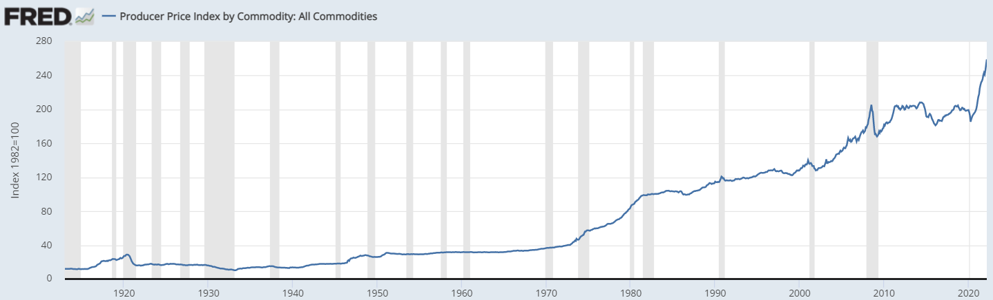*Figure 8 illustrates the rise of commodity prices which have a correlation to the lack of containers being supplied.*

Commodity prices increased because of the negative effects on the modality in which it was being transported – shipping containers. There was a shortage of containers and container ships during the pandemic. There were many reasons for this shortage: trade imbalances, and changes in trading patterns, which changed the routes to which the containers would be shipped. As a result, containers were being shipped to unintended places and causing a mismatch between the supply and demand of containers. These leave containers left behind or repositioning these containers to the right location, this increases the expected dwell time of these containers in the ports. As a result, this affects the industry as a whole, but ultimately, this increases delays in shipping. We can see this in the data from the Port of Los Angeles (POLA). Where they have recently released data on how long the containers have been anchored and berthed in their port and how many vessels were being docked in POLA, as seen below in *figure 9*.

*Figure 9:*

|  |  |  |  |  |  |
| --- | --- | --- | --- | --- | --- |
| **Year** | **Average POLA Vessels at Anchor** | **Average POLA Vessels at Berth** | **Average POLA Vessels Departed** | **Average Days at Berth** | **Average Days at ANC + Berth** |
| **2019** | 0 | 9 | 3 | 3 | 3 |
| **2020** | 2 | 10 | 3 | 3 | 3 |
| **1/2/2020 - 2/28/2020** | 0 | 7 | 2 | 3 | 3 |
| **3/2/2020 - 12/31/2020** | 2 | 11 | 3 | 3 | 4 |
| **2021** | 17 | 16 | 3 | 6 | 13 |

Figure 9 measures the number of vessels and days spent anchoring and berthing at the Port of Los Angeles.

From selecting the years 2019 to 2021, my intention is to observe the years of port activity in pre-pandemic versus post-pandemic pandemic years. In addition, I’ve split the year 2020 into two parts – when COVID-19 was declared a global pandemic, which was in March 2020. From splitting the two portions of the dates, pre-pandemic and post-pandemic, we want to see the differences in port activities. Immediately, we can see that in the years 2019 and 2020, the averages of each line item are almost identical. However, the differences in port activity change by looking at the start of March 2020, when the average vessels at anchor and berth have increased. Moreover, the average days spent at anchor and berth have increased as well. When vessels are berthed, this means that the vessel is to be parked for the purpose of unloading the containers. When a vessel is anchored it is in the process of it being berthed and unloading its containers. According to the table, there has been a rise in the number of vessels being anchored and berthed and consequently, the average days being spent in the port has increased. Furthermore, observing in the year 2021, all line items, except the average vessels departing from POLA, have significantly increased, especially the average vessels being anchored, berthed, and the amount of time spent in POLA. In the year 2022, signs have not shown any improvement. The average POLA vessel at anchor is a clear indication that there is congestion in POLA. In December of 2021, 100+ vessels have been spread across 1,000 miles of the coast of California, waiting for a berth space at the Port of Los Angeles and Port of Long Beach, where storms are not uncommon. These vessels are waiting to be cleared to unload the containers. This is an exact result of the container crises we currently face due to the pandemic. It is a reflection of a slowdown in and the delays across the maritime supply chain due to the pressure from COVID. This displays that there are labor shortages in the industry, and experiences in port congestions, which spillover effects will happen in the industries of transportation and to its final goods. This affects the prices due to the delay in receiving its shipment. To add to the delays in shipping to the container crises, there have been shortages in containers.

The shortage of containers has been an additive to the container crises, due to the cascading effects of the global pandemic. The majority of containers have been stuck in cargo ports and the rest on vessels, especially vessels traveling down the transpacific lines – Asia being the most negatively affected by container shortages. Asia, a global exporter to the world, and it is the epicenter of the pandemic, created a domino effect in trade because many of its facilities and factories shut down because of COVID. To stabilize costs, these factories had to reduce the number of vessels being sent out to sea. Just like what was mentioned before, this had to change the balances of imports and exports between countries, however, this also meant that there were empty containers that were not retrieved from North America. The nature of ripple effects is that there are delays in how countries experience events. Although Asia was the first to experience COVID, they were also the first to recover from it. So, the longing of them wanting to retrieve their empty containers from North America and Europe, they did not return quick enough. North America and Europe were still managing their COVID situation in their regions, which applied pressure on their labor market. Without adequate staffing, the containers began to accumulate and that accumulation had compelled novel ideas on how to return these empty containers, especially since borders began to tighten. So, there were rapid shifts in route demands that caused massive challenges in the industry. With limited staffing and with the amount of work to compensate for the backlog of containers, there was no fair chance of returning the empty containers in time. Even now, North America faces an imbalance in containers; for every 100 containers, 40 are only exported. Also indicating that 60% of the containers are being accumulated; a staggering amount of containers because the China to USA trade route averages 90,000 twenty-foot equivalent unit (TEU) freights per month. This frequent number is during a time of normalcy, which can be higher by 20% during busier seasons. In Figures 9 and 10 below, these are the numbers of containers coming in and out of the Port of Los Angeles and Long Beach, respectively.

*Figure 10:*

|  |  |  |  |  |  |  |  |
| --- | --- | --- | --- | --- | --- | --- | --- |
| **Port of Los Angeles** | | | | | | | |
| **Year** | **Loaded Imports** | **Empty Imports** | **Total Imports** | **Loaded Exports** | **Empty Exports** | **Total Exports** | **Total TEUs** |
| 2019 | 4,714,266 | 149,579 | 4,863,845 | 1,756,177 | 2,717,611 | 4,473,788 | 9,337,632 |
| 2020 | 4,827,040 | 49,311 | 4,876,351 | 1,531,406 | 2,805,639 | 4,337,045 | 9,213,396 |
| 2021 | 5,513,286 | 26,707 | 5,539,993 | 1,184,145 | 3,953,472 | 5,137,617 | 10,677,610 |

*Figure 11:*

|  |  |  |  |  |  |  |  |
| --- | --- | --- | --- | --- | --- | --- | --- |
| **Port of Long Beach** | | | | | | | |
| **Year** | **Loaded Inbound** | **Loaded Outbound** | **Total Loaded** | **Empties Inbound** | **Empties Outbound** | **Total Empties** | **Total Throughput** |
| 2019 | 3,758,438 | 1,472,802 | 5,231,240 | 74,706 | 2,326,087 | 2,400,792 | 7,632,032 |
| 2020 | 3,998,340 | 1,475,888 | 5,474,227 | 146,370 | 2,492,718 | 2,639,088 | 8,113,315 |
| 2021 | 4,581,846 | 1,437,916 | 6,019,762 | 154,289 | 3,210,317 | 3,364,606 | 9,384,368 |

The numbers displayed above are from the years 2019 to 2020, imports and exports, whether empty or not, per port. From the years 2019 – 2020, there has been an increase in the total amount of empty containers. In POLA, the total amount of empty containers in 2021 was 5,164,324 from 4,386,356 in 2020 – this was an increase of 18%. The Port of Long Beach also experienced the same sentiment in the increase of the total empty containers. In year 2020, the total amount of empty containers was 2,639,088 and in 2021, 3,464,606 – a 27% increase. As you can see, there is a huge imbalance between the total amount of inbounded and empty containers that were outbound. This is the exact reason why empty containers have been stockpiling, causing a container shortage since these empty containers are not going to their respective destinations. With this container shortage and the limited amount of labor due to the COVID shutdowns in all businesses, meeting the high demand was challenging to say the least. As a result, this had pushed freight costs at a rate never before, which can be seen in *Figure 12.*

*Figure 12:*

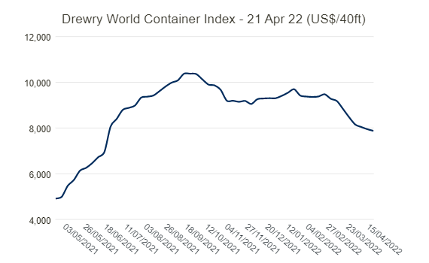

*The Drewry World Container Index measures freight rates of 40 ft containers and when COVID was declared it ascended in prices.*

At the peak of it all, in September 2021, freight costs reached an all-time high of $10,375 per 40-foot container. To put things into perspective of how much rates have increased, in September 2019, the same container cost less than $1,500 – seen in *figure 13.*

*Figure 13:*

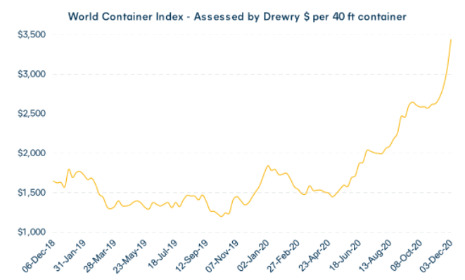

This graph illustrates the dramatic increase in freight rates of 40 ft containers before and after the start of COVID.

To make matters worse, the production of containers has declined rapidly, due to the bottlenecks and trade imbalances. The rate of production was already down in 2019 but is woefully lower because of the pandemic, which can be seen in *figure 13.* It has declined so low, that the scrapping of containers has surpassed the number of containers produced, in the year 2020. Consequently, the number of container factories will have less inventory, as seen in *figure 14.*

*Figure 14:*

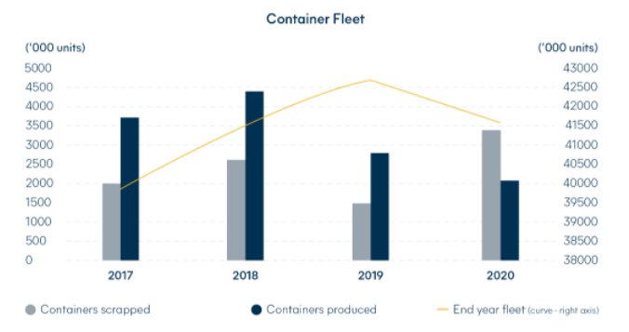

Figure 14 is displaying the changes in the amount of containers produced and scrapped. The amount of containers scrapped is surpassing the amount of containers being produced.

*Figure 15:*

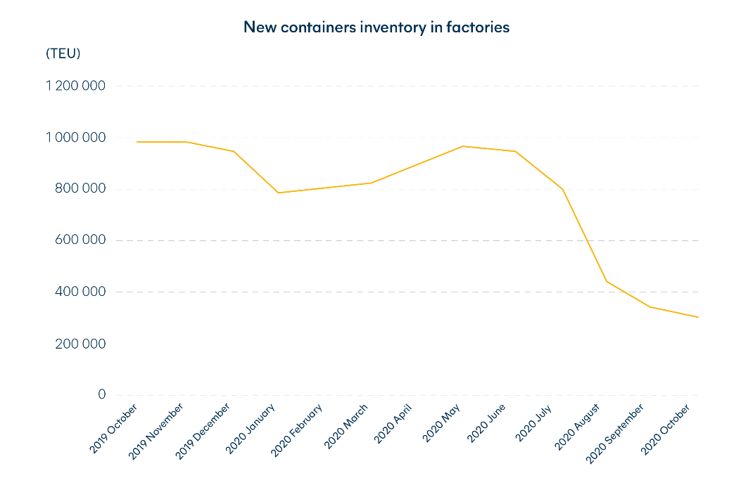

*Figure 14 shows that there is a decline in new containers inventory in factories and has sharply declined due to COVID.*

With the access of container being limited, this has driven the prices of new containers since manufacturers understand the dire need of them. Similarly, the container leasing rate has also risen dramatically.

**Model Overview:**

The model that I intend to use is the following:

The consumer price index will act as the dependent variable for inflation, which is classified as “INFLATION” in the regression results. The independent variables that will explain inflation are the expected inflation rate (EXPINFLATION_T_5), freight (FREIGHT_T_5), money supply (M1_T5), oil (Oil_T_5), trucking (TRUCKING_T_5), unemployment rate (UNRATE_T_5). Each period represents one month, and these variables are lagged by 5 time periods. The reason why these variables were lagged by 5 months is because, in my data with the Port of Los Angeles, the average days of vessels have increased, deviating from the average berth days at the docks. The variables oil, trucking, and freight will act as the supply side, which was caused by the disruption of the supply chain. Unemployment, money supply, and the expected inflation rate will act as the demand side - the effects of the monetary policy, QE. The time period that will be analyzed is from 2008, starting April to November 2021.

**Regression #1 Results:**

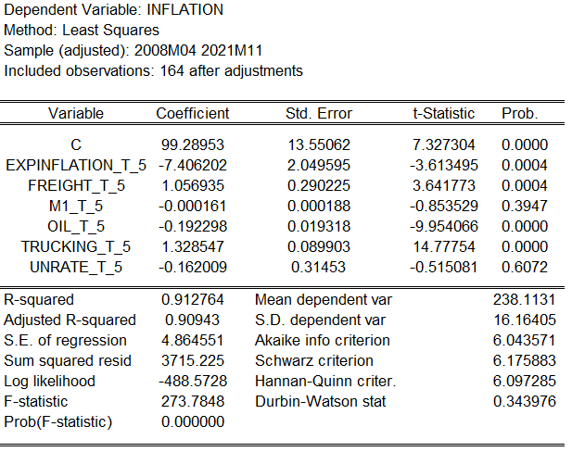

At first glance, we can see that there are two variables, money supply and unemployment rate, that are not statistically significant in attempting to understand inflation. This is contrary to what theory says. In addition, the of the regression is high, 91%, and the Durbin-Watson statistic is low. This infers that there is serial correlation in the variables, furthermore, perhaps a spurious regression. Another issue is that the expected inflation rate decreases inflation by 7.4 percentage points if it were to increase by one percentage point. A solution to the spurious regression problem and serial correlation, taking the first difference of each variable and its dependent variable is an approach that can be made, plus, regressing using the Newey-West estimator.

**Regression #2 Results:**

The model that I intend to use is the following:

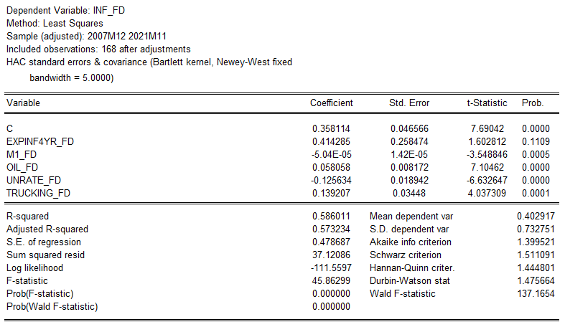

After conducting this regression, it improved the results greatly. Nearly all the variables are statistically significant at a 1% level, except the expected inflation rate variable. By taking the first difference of each variable, it reduced the serial correlation of the regression. By reducing the serial correlation further, I’ve omitted the freight variable, since freight and trucking are correlated with another. As a result, we can see improvements, through the significant increase of the Durbin-Watson statistic. In addition, the expected inflation rate is now positive, which was an issue in *Regression #1*, however, fails to be significant at a 10% level, but is close to passing with 11%. I’ve replaced the time-frame of the expected inflation rate with multiple time frames – 3-year, 6-year, 7-year, 10-year, 20-year, and 30-year. The 4-year expected inflation rate was the best time frame of the selections. The reason for altering the expected inflation rate was to reduce the p-value of the variable so that it could be significant at a 10% level.

The results of the regression align with my statements about inflation. QE has been prevalent since 2007, during the recession. However, during that time, inflation was not declared, but this time it is. We can see that the M1 money supply has hiked immensely, but it was not solely from QE; it had to do with the methodology change. We can see this in the regression results because the M1 money supply virtually does not change inflation whatsoever. On the other hand, we can see that trucking has increased inflation, which is profound, because it explains the price hikes that the trucking industry has to offer, due to supply chain disruption. During the time of COVID-19, truck drivers were paid much more because there was a shortage of drivers. Truck drivers’ salaries have increased from $40,000 to $70,000 in 2021. This increase in salaries is a reflection of the trucking variable. In Regression #2, it’s clear that the PPI for the industry of freight trucking increases inflation more than the money supply. With the increase of one percentage point in freight trucking PPI, it is to increase inflation by 12 percentage points at a 1% significance level. This is profound in the sense that the majority believes that inflation was caused by quantitative easing, and the contrary. There are more reasons for the supply chain to be a cause of it, due to the statistical significance of the variable, trucking.

COVID-19 had shocked the world. It shocked both supply and demand. Suppliers were not able to provide the necessary goods in a timely fashion. Shortages occurred, consumers changed the way they purchased items, prices increased significantly, and the list goes on. To alleviate the economic damages that were caused, the government decided to execute quantitative easing to help consumers purchase necessary goods since unemployment had increased, which was caused by businesses shutting down momentarily or in some cases, indefinitely. Work was considered to be foreign. However, there were industries that were considered necessary, and trucking was one of them. People still needed things. To put it shortly, supply had decreased, but demand was increasing, and naturally, this increased the price of goods. Lo and behold, inflation was declared, which was driven by the actions of the Federal Reserve. Memes were created of Jerome Powell printing an “infinite” amount of money, to satisfy the demand of unemployed citizens. However, because of a huge shortage of workers, replenishing the needs and demands of everyone, caused a strain on the small lump sum of workers, which introduces the idea of *convexity* by Taleb. Mentioning that it requires much more work to compensate for the lack of productivity from the beginning of COVID; there was so much backlog in the supply chain. Vessels upon vessels were parked in the ocean, waiting for their turn to unload their freights by the docks. The average days of waiting have nearly doubled during COVID, and sometimes, quintupled the wait. This caused so much uncertainty for businesses, and to reduce the likelihood of default, inventories were cut to reduce costs; even during the time of when freights were on its way to the docks. This was the supply chain disruption. Routes were changed, vessels were rerouted, and freights were lost.  As a result, this had exacerbated prices to increase further. Yet, the blame was still against quantitative easing for the sin of inflation. Unbeknownst by many, the methodology for the increase of M1 money supply had changed, in discretion as well. Saving deposits and money funds that were in the M2 money supply were included into the M1 money supply, seemingly making the M1 money supply increase tremendously in *figure 2*, but in reality, there was just a methodology change. These saving deposits and money funds, according to Regression #2, show very little changes to inflation. However, by observing the trucking variable, which is affected by the supply chain disruption, inflation increases by 12 percentage points if the coefficient were to increase by 1 percentage point. In addition, the variable is statistically significant at a 1% level. It’s a case that quantitative easing is not the sole reason for inflation, and arguably, not a case at all. The real cause of inflation is the disruption of the supply chain.

*References:*

1. Acemoglu, D, Tahbaz-Salehi, A. (2020). “Firms, Failures, and Fluctuations: The Macroeconomics of Supply Chain Disruptions”. MIT Economics Papers
2. *Flexport glossary term: Blank Sailing*. Flexport. (n.d.). Retrieved April 22, 2022, from https://www.flexport.com/glossary/blank-sailing/
3. Manaadiar, H. (2021, December 12). *Export Container Dwell Times Soar at main ports globally as berthing delays bite*. Shipping and Freight Resource. Retrieved April 22, 2022, from https://www.shippingandfreightresource.com/export-container-dwell-times-soar-at-main-ports-globally-ports-as-berthing-delays-bite/#:~:text=Container%20dwell%20time%20measures%20the,in%20the%20case%20of%20exports
4. Nassim Nicholas Taleb (2016). Antifragile: things that gain from disorder. New York: Random House.
5. Nelson, Edward. (2007). “Milton Friedman on Inflation”. Federal Reserve Bank of St. Louis Economic Synopsis, Number 1.
6. Santacreu, A.M. and LaBelle, J. (2022). Supply Chain Disruptions During the COVID-19 Recession. Economic Synopses, 2022(2).
7. *POLA: Container statistics*. Container Statistics | Port of Los Angeles. (n.d.). Retrieved April 22, 2022, from https://www.portoflosangeles.org/business/statistics/container-statistics
8. *Port congestion update 2/17/22*. Western Overseas. (2022, February 22). Retrieved April 22, 2022, from https://www.westernoverseas.com/port-congestion-update-2-17-22/
9. *State of the industry 2020: Ocean Shipping Weathers the pandemic*. Hillebrand. (n.d.). Retrieved April 22, 2022, from https://www.hillebrand.com/media/publication/state-of-the-industry-2020-ocean-shipping-weathers-the-pandemic
10. *Where are all the containers? The global shortage explained*. Hillebrand. (n.d.). Retrieved April 22, 2022, from https://www.hillebrand.com/media/publication/where-are-all-the-containers-the-global-shortage-explained#:~:text=An%20unforeseen%20cascade%20of%20events,trade%20on%20a%20global%20scale
11. *World container index - 21 Apr*. Drewry. (n.d.). Retrieved April 22, 2022, from https://www.drewry.co.uk/supply-chain-advisors/supply-chain-expertise/world-container-index-assessed-by-drewry